**Introduction to Maven**

* **Maven is a build automation Tool. (It makes the project build process easier)**
* **It can be used with a lot of Programming languages such as C, C++, Java, PHP and Scala etc.**
* **Maven can be used from the command prompt or it can also be integrated with several existing Java IDEs.**

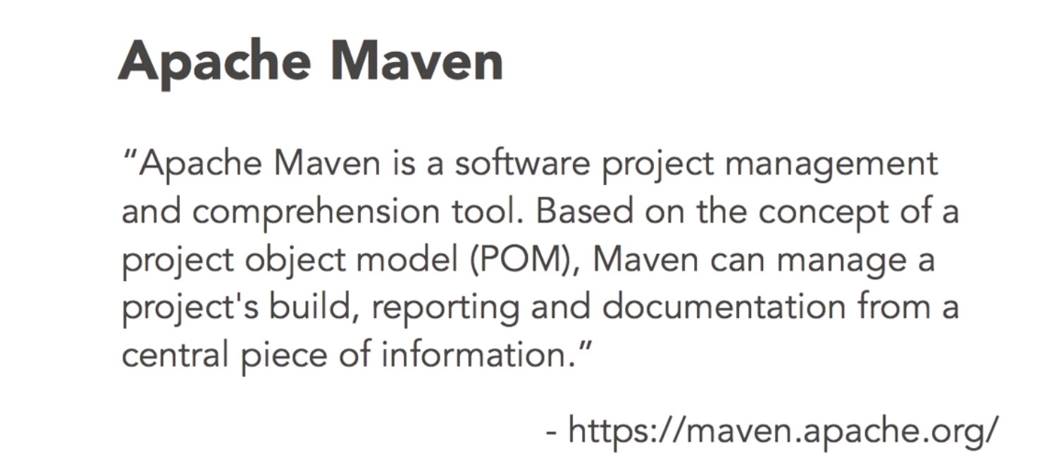

* **Maven is defined to provide simple project.**

**Apache Maven**

* **Projects follow a consistent Structure.**
* **Projects become loosely coupled with IDEs.**
* **By forcing a consistent structure of a Project it makes modification Easier for future when new developer is introduced to the project.**
* **It also ensures that programmers always get the latest version of compilers and dependencies.**

To work with Maven:

* Good Internet Connection

How to set up maven in Eclipse IDE:

* File -> New -> Maven Project
* Make sure that you are in the default workspace ( There should be a ticked checkbox ) -> Next
* Select an Archetype ->
  + For Simple Java Project:
    - select: maven-archetype-quickstart
* For Web Project:
* select: maven-archetype-webapp
* group id, artifact id, version are important fields for maven, Using this field maven uniquely identify a project.
* Finish